Toad in the Hole and Onion Gravy

Ingredients
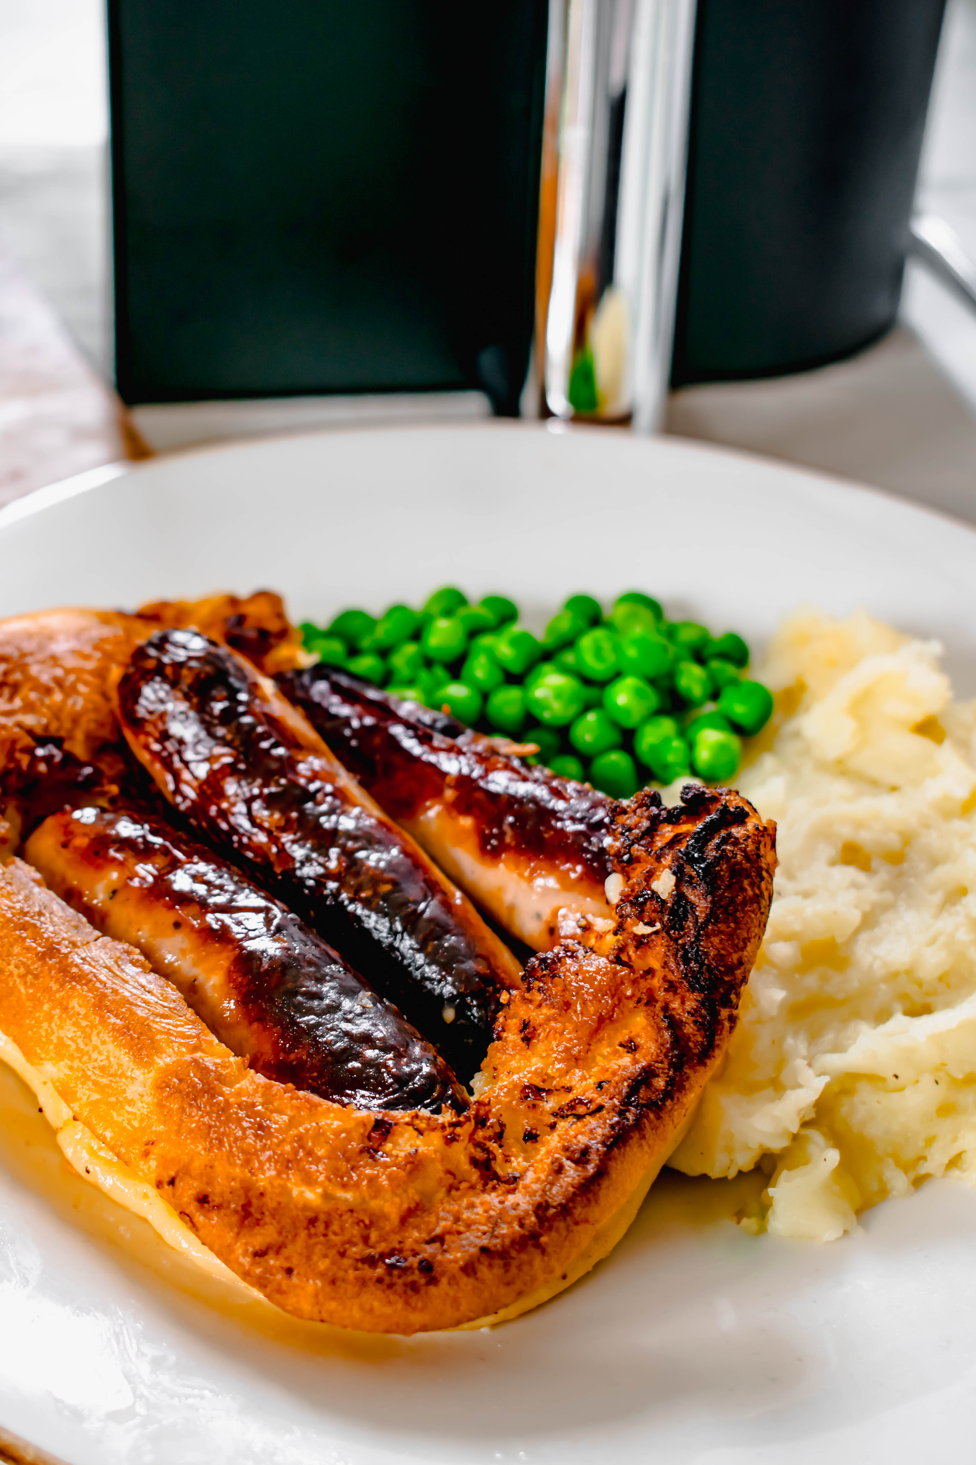

Toad in the hole
- Vegetable oil
- 100ml milk
- 50g plain flour
- 1 tsp wholegrain mustard
- 2 sausages
- 1 egg

Onion gravy
- ½ large onion
- 1 tbsp oil/butter/margarine
- 2 tsp plain flour
- ½ beef stock cube
- 150ml water
- 1 tsp Worcestershire sauce
- Salt and paper to taste

Method
- Pre heat the oven to 200C.
- Grease a small oven proof dish
- Whisk the egg and milk together in a bowl
- Sift the flour into another bowl. Slowly whisk the egg mixture into the flour. Whisk in the mustard.
- Put the sausages in the dish and pour over the batter. Place dish on a baking tray.
- Bake in the oven for 15-20 minutes, set timer or until batter is puffed up and golden brown.
- Whilst the Toad in the Hole is baking, slice the onions.
- Melt the oil/butter/margarine in a saucepan over a medium heat.
- Add the onions and cook for 10-15mins stirring regularly until soft and golden brown.
- Add flour, stir well and cook for 1 minute.
- Gradually add stock stirring all the time, allow to thicken after every time you add stock. Add the Worcestershire sauce. Simmer for 5-10 minutes.
- Season with salt and pepper

